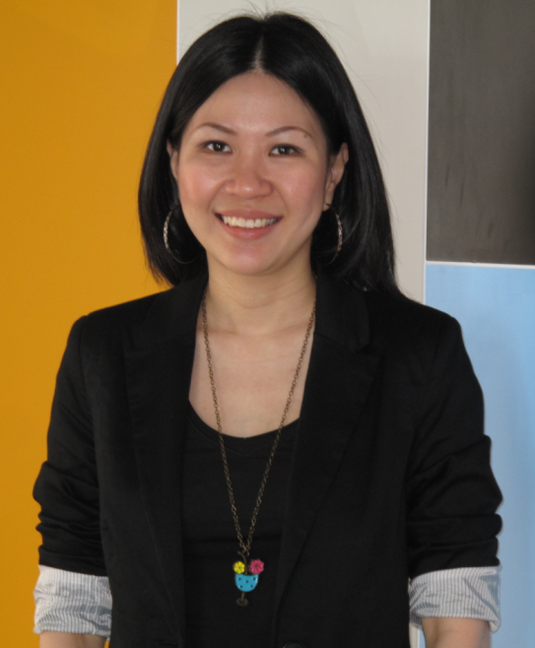
Lim Soon Lee
soon_lee_lim@hotmail.com
+62 811 940 7829

_____________________________________________________________
Career objectives:
Looking for new opportunities in Indonesia to leverage my 16 years experience in the market research industry; of which 11 years were spent in senior management/country manager position focusing primarily on developing and executing business plans & strategies to deliver company growth, launching of new panels and advanced analytics solutions, pushing marketing, delivering insights, drive business development and client partnerships

Work experiences:
General Manager
Kantar Worldpanel Indonesia (a WPP/Kantar company)
June 2011 until present
Key responsibilities:
- Launch and setup the consumer panel business in Indonesia with a large sample size of 7,000 households in a highly competitive situation
- Drive the business from “ground zero” to now having over 25 clients
- Responsible for budget planning, strategic planning for the entire commercial and operations team
- Responsible for the P&L/financials of the company
- Team management, leadership and training/coaching for both the operations and commercial team
- Drive new business development; responsible for setting up a new business development team
- Build the name of Kantar Worldpanel in Indonesia through intense marketing efforts – r setting up a full time marketing team
- Manage the operations team to deliver best in class data quality
- Deliver consumers insights and foresights to top management and clients in the FMCG and retail industry
- Joining the dots in data to tell a story that makes a difference to clients businesses
- Driving digital solutions with clients like Facebook etc

Director, Consumer Panel Services & Advanced Analytics Consulting
The Nielsen Company Indonesia
June 2005 until May 2011 (6 years)
Key responsibilities:
- Head up the Consumer Panel Services and Advanced Analytics Consulting businesses for Nielsen Indonesia – fully responsible for the P&L
- Drive business development for both businesses
- Manage the entire client servicing team for Consumer Panel Services and the client consultants for Advanced Analytics Consulting
- Executes and delivers all Advanced Analytics Consulting projects as the key consultant – Market Mix Modeling, Price Modeling, Price and Promotions Modeling
- Work with clients to understand their key business issues to drive solutions through advanced analytics
- Drive innovation for both businesses
- Involve in integration processes with all other business units in Nielsen Indonesia
- Inspire team to uphold supreme levels of client servicing and provide top class analyses to clients
- Deliver consumer insights to top management, key clients
- Develop and execute growth strategies

Senior Business Development Manager (Jan 2005 – June 2005)
Account Executive - Senior Account Manager (Feb 2001 – Jan 2005)
TNS Worldpanel (now Kantar Worldpanel)
Feb 2001 - June 2005, Malaysia (4.5 years)
Key responsibilities:
- Managed the biggest account – Colgate Palmolive and a host of other key clients (Coca-Cola, Glaxo Smith Kline, Lion, Tesco, L’Oreal etc)
- Drive business development
- Deliver insights to clients through presentations, workshops, brand planning cycle etc
- Train, coach and manage team members
- Deliver against account plans of the key clients under my portfolio
- Deliver against revenue targets

Business Development Executive
Zubeby (M) Sdn Bhd – a soft skills training consulting firm
July 2010 – Jan 2011, Malaysia

Financial Consultant
Hong Leong Finance Berhad
July 2009 – July 2010, Malaysia

Key achievements with Kantar Worldpanel Indonesia
- Since taking on the role in June 2011 from a base of “zero clients and zero revenue”, the business hit 1.3 million USD revenue in 2014, 2.54 million USD in 2015 and set to deliver 4.2 million USD in 2016 – in a competitive situation where competitor is heavily cutting and driving down price
- Selected to participate in World Class Leaders, Global HiPo programme where I will be working and engaging directly with global Kantar Worldpanel board team
- Member of WPP High Potential Group (HPG) – which is a highly selective group of CEOs in WPP who are exceptionally high potential. This membership comes with allocation of WPP restricted stock as an additional benefit
Key achievements with The Nielsen Company Indonesia
- Alumni of Nielsen Leadership Program (NLP) 2009 - a six days leadership program held at Duke University, North Carolina, USA.
Nielsen Leadership Program (NLP) is the most prestigious leadership program within The Nielsen Company which started in 2008. This program is designed for the most outstanding leaders within The Nielsen Company globally. Only the “best of the best” 30 leaders are selected from Nielsen worldwide to attend this program each year out of the 34,000 employees in the company. I was selected to attend NLP 2009 (second year of the program). In this leadership program, participants get to meet and dialogue face to face with Nielsen Executive Committee members - including the CEO, David Calhoun and his direct reports. It is really one of the highest recognition any Nielsen employee can receive while working with the company

- Entrusted to head up the Nielsen Advanced Analytics Consulting (AAC) business in Sept 2009 – until I left the company

Prior to heading up this business, Nielsen Indonesia did not have a full time local resource driving the business, rather was relying on regional resources. I was given the trust to expand my role and take on responsibility to drive this business for Nielsen Indonesia. It was an honour as well as a real privilege to be given the chance to learn and master advanced analytics in the world of research. In that role, I grew the business by 120% in less than one year and continued to drive high growth in 2011

- Grew the Nielsen consumer panel business from being a 500k USD business in mid 2005 when I first joined to a 3+ million USD business by 2011 when I left (business size grew by 6 times under my leadership).

Key achievements with TNS Worldpanel Malaysia (now Kantar Worldpanel)

- Grew the Colgate Palmolive account to be the biggest account from 100k USD to a 350k during the 4.5 years when I held the account
- Acted as trusted advisor to Colgate Palmolive account – with engagement level to Managing Director level – always get invited to every brand planning cycle by the Managing Director
- Entrusted the full time role of business development in January 2005

Expertise:

- Consumer Panel diagnostics analyses – have spent the last 16 years working in consumer panels
- Advanced Analytics:
1) Price Modelling - price elastiticies and cross price elasticities
2) Promotions Modelling – promoted price elasticities and causal coefficients
3) Marketing ROI modelling - Marketing Mix Modelling, Digital ROI measurement
4) Assortman modelling
5) Market Structure - consumers purchase decision hierarchies
6) EnReachTM - custom analytics for the Traditional Trade
7) Other custom analytics
- Surveys and Segmentation
- Retail Measurement Services (Retail Audit) - fully proficient
- Customized Research - good knowledge to engage with clients and be able to integrate findings and results
- Story telling; piecing together insights; combining different data sources - integration
- Business development
- Strategy development
- Innovation

Others:
- Studied at University Putra Malaysia – Bachelor of Science Bioindustry (majoring in Agricultural Economics, Second Class Upper honours)
- Date of birth 26 August 1977
- Marital status: Married
- Children: 3
- Languages: Written – English, Bahasa Malaysia, Bahasa Indonesia. Spoken: English, Bahasa Malaysia, Bahasa Indonesia, Hokkien, Cantonese

References available upon request

